<cn> End of Chapter Questions <ct>The Cover

End of Chapter Questions produced by Dr Stephen Dann.

If you need to contact me during the semester, I can be reached through one or more of the following systems.

|  |  |
| --- | --- |
| **Websites** | |
| E-marketing book support site | [**http://contemporaryemarketing.co.uk/**](http://contemporaryemarketing.co.uk/) |
| About.me | [**https://about.me/stephendann**](https://about.me/stephendann) |
|  |  |
| **Questions?** | |
| Formspring.me | [**http://www.formspring.me/stephendann**](http://www.formspring.me/stephendann) |
| Quora | [**http://www.quora.com/Stephen-Dann**](http://www.quora.com/Stephen-Dann) |
| **Community** | |
| Steam | [**http://steamcommunity.com/id/stephendann**](http://steamcommunity.com/id/stephendann) |
| Xbox Live | **Gamertag: stephendann** |
| **Contact Points (goes to my computer)** | |
| Twitter | [**@stephendann**](http://twitter.com/stephendann) |
| Standard E-mail (work account) | [**Stephen.dann@anu.edu.au**](mailto:Stephen.dann@anu.edu.au) |
| MSN (work account) | [**stephendann2003@hotmail.com**](mailto:stephendann2003@hotmail.com) |
| **Really Urgent (goes to my phone)** | |
| E-mail | [**Stephen@stephendann.net**](mailto:Stephen@stephendann.net) |
| MSN | [**sddc_awayteam@live.com**](mailto:sddc_awayteam@live.com) |

<cn>End of Chapter Questions <ct>The Preface

[Each EoC Question set opens with a Wordle image of the chapter content]



<cn>End of Chapter Questions <ct>The Preface 1

<lo>Learning objectives 6

<EoC> Knowledge (10) Multiple Choice 7

<EoC> Comprehension (4) Short Answer 8

<EoC> Application (3) Practical 9

<EoC> Analysis (1) Theoretical 10

<EoC> Synthesis (2) Creative Project 11

<EoC> Evaluation (1) Essay Question 13

Author notes:

**Versions**

Two versions of the End of Chapter questions are provided – one with the answers, and one that is just a straight list of the questions. We always found it annoying to have to strip the questions out of the instruction material to post onto the site.

* Chapter 01 Q 1.0 Question set
* Chapter 01 Q and A 1.0 Questions and answer guides

**Pedagogy**

The EoC Questions are based on the [Bloom Taxonomy of Learning Domains](http://www.amazon.com/gp/product/0582280109?ie=UTF8&tag=stephendannne-20&linkCode=as2&camp=1789&creative=390957&creativeASIN=0582280109) as the platform for the questions.

*Bloom B. S. (1956).* [*Taxonomy of Educational Objectives*](http://www.amazon.com/gp/product/0582280109?ie=UTF8&tag=stephendannne-20&linkCode=as2&camp=1789&creative=390957&creativeASIN=0582280109)*, Handbook I: The Cognitive Domain. New York: David McKay Co Inc.*

Bloom’s taxonomical structure assumes the existence of a step-wise approach to education, learning and understanding in which it is possible to move through seven levels which sequentially build into a deep insight into a topic.

*Knowledge*: which represent the core level of memory, the ability to recall information on command, and generally forms the foundation for the next levels by having the component parts of information and knowledge available for application and use. This level is translated in the multiple choice question set which tends towards the recall of definitions, facts and other basic components.

*Comprehension*: The second level of the taxonomy relies on a core of knowledge which is then able to be interpreted into the student’s own words, and constructed in a way that shows both the ability to interpret and translate prior learning. The nature of the comprehension questions as translations and interpretations has been used for the short answer questions. The short answer questions are also based on the learning objectives for the chapter, and provide a direct outcome for students based on the objectives of the chapter.

*Application*: The application level is training for extracting the purpose and point of the materials in the chapter, and applying them to sections of the internet in ways that weren’t covered in the book. It tends towards the practical (do X), or the categorical (Collect X) with the intention that the students have a chance to take a few unexplored paths and put their coursework to use.

*Analysis*: This type of question is usually centered around a key model from the chapter which the students must either deconstruct, or which requires them to understand the wiring behind an idea, model or table. The aim of the question is to have the students investigate the organizational structure of the idea so they can better understand the how and why elements whilst still using the basic principles.

*Synthesis*: The two synthesis questions relate to the two semester length (or book length) exercises of either performing a Marketing Technology Analysis or planning, creating and assessing a blog. The idea of the synthesis question is to build a structured outcome from a series of parts which, when combined in this process, would form something new (eg the MTA or the blog).

*Evaluation*: The final layer of questions in the EoC material are designed to be potential candidates for essays, major assignments or end of semester exams. The aim of these questions is to allow students the opportunity to make judgments about the value of an idea, and to justify their judgements and extending the application of what they have researched with original insights from their own experience.

The interconnection of the approaches, and choice keywords that can be used in the related types of questions are outlined in the figure below. (There’s a link to the highest resolution copy of the illustration after the image)

Figure 1. Bloom’s taxonomic rose.

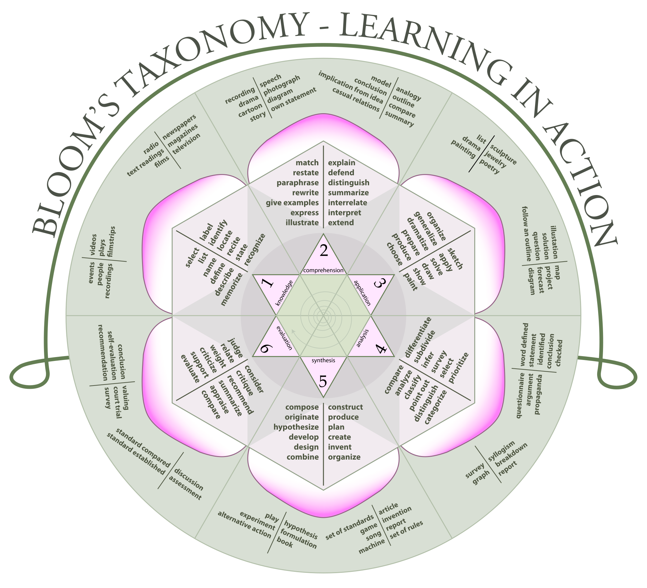

Aainsqatsi, K. (2008) Bloom's Rose, <http://en.wikipedia.org/wiki/File:Blooms_rose.svg> CC-BY 2.5.

This image is licensed under the [Creative Commons](http://en.wikipedia.org/wiki/en:Creative_Commons) [Attribution-Share Alike 3.0 Unported](http://creativecommons.org/licenses/by-sa/3.0/deed.en) license, and may be shared and remixed under the conditions of attribution to the original source ([Aainsqatsi](http://en.wikipedia.org/wiki/File:Blooms_rose.svg)) and share alike (If you alter, transform, or build upon this work, you may distribute the resulting work only under the same or similar license to this one.).

Another useful list of the keywords comes from <http://www.nwlink.com/~donclark/hrd/bloom.html>

<lo>Learning objectives

By the end of this chapter, you should:

* Be conversant with the End of Chapter Question Set template
  + Be aware of some of sub-features in the template
* Have some insight into the selection of the questions, and the theory and motivation behind their development

</lo>

The learning objectives for the chapter are included in each of the EoC question sets, and provided guidance for the development of the EoC question content for the pedagogical benefits, and because it’s always nice to be able to convert a set of objectives into goals, behaviours and metrics. Having the students act on the areas we’ve suggested would be ideal outcomes from the chapter will also provide them with the bonus experience of implementing an outcome (albeit possible by stealth. Few students know their pedagogical method at this point).

<EoC> Knowledge (10) Multiple Choice

Multiple Choice Questions: There are ten multiple choice questions per EOC set. The Multiple Choice questions may be used as revision or may be able to be stockpiled for an end of semester exam (or both if you want to recycle the content).

Each question also features a small amount of meta-data in the form of the Answer (Answ:), a graded rating of the difficulty of the question, and the page number reference from the book. The graded scale translates as:

* [1] Recall or memory centric question. Definitions, concepts and straightforward feature lists.
* [2] Application of multiple concepts, or requires the students to distinguish between closely related concept. Slightly challenging and harder to determine the answer by elimination.
* [3] May draw on multiple ideas from the current chapter, or draw on a combination of the current chapter and prior chapter. Alternatively, it’s just difficult and requires higher levels of judgement

1. [Question drawn from materials covered somewhere in the text]
   1. [answer 1]
   2. [answer 2]
   3. [answer 3]
   4. [answer 4]
   5. all of the above

Answ: [ ] Diff: [1] [2] [3] Page: [ ]

<EoC> Comprehension (4) Short Answer

The Comprehension questions are all based on the learning outcomes. There is a direct link between what the chapter sets out to explain, and the questions that are asked in this section. The questions tend to draw on multiple sections of the chapter, and can also integrate elements of previous chapters where necessary and where it suits the learning objectives of the chapter. As with the multiple choice questions, there’s a difficulty grading, and references to the pages in the chapter that would assist with the question. Sample answers to the comprehension questions tend towards describing the processes, or styles of answer, rather than producing template responses since the purpose of these exercises is to encourage students to reimagine the content in their own words.

Difficulty Rating (Diff)

* [1] Focuses on a more specific portion of the chapter. Answers can be relatively self contained within the information provided in the chapter.
* [2] Focuses on two or more specific portions of the chapter. Answers can still be self contained within the information provided in the chapter, although broader internet application may be required.
* [3] May draw on multiple ideas from the current chapter and the internet experience, or draw on a combination of the current chapter and prior chapters.

1. [Question]

Diff: [1] [2] [3] Page: [ ]

Answer: [Answer goes here]

<EoC> Application (3) Practical

The application questions are practical exercises designed to have the students use the internet to answer the questions, or to undertake practice sessions with systems, services or sites. Questions will often include reference to models, checklists, tables or diagrams from the chapter, as the purpose of these questions is to create opportunities for students to apply what they’ve read in the chapter. Questions may also refer the students back to Chapter 0 as a starting point for examples, samples and webservices.

Difficulty Rating (Diff)

* [1] Answers can be relatively self contained within the information provided in the chapter, and examples are relatively straight forward to source.
* [2] Answers can still be self contained within the information provided in the chapter, although broader internet application may be required, and students will need to consider ideas from previous chapters.
* [3] Answers will require research, drawing on multiple ideas from a range of chapters, and internet experiences.

1. [Practical question requiring the use of the internet]

Diff: [1] [2] [3] Page: [ ]

Answer: [Answer goes here]

<EoC> Analysis (1) Theoretical

Theoretical questions are based around a key idea, theory or model from the chapter which is provided to the students to either be expanded, re-explained, or reinterpreted. This type of question tends to span multiple chapters, and is suited to being used for assessment purposes

Difficulty Rating (Diff)

* [1] Referenced theory is contained within the chapter and the book.
* [2] Referenced theory is spread over multiple chapters. May be assisted through the use of Google Scholar.
* [3] Will require the use of Google Scholar. Theory links to a wide range of sources external to the text and the subject.

1. [Question about theory, model or idea]

Diff: [1] [2] [3] Page: [ ]

Answer: [Answers to this question will either take the form of marking criteria, or suggestions, guidelines or advice as the questions should evoke unique responses from the students.]

<EoC> Synthesis (2) Creative Project

The synthesis questions present an ongoing and interconnected series of sub elements of two larger projects. Depending on your course work preference, either of these projects could form the major assignment for the semester – they probably couldn’t be run in parallel though, as they’re meant to be large ongoing tasks.

1. Ongoing Blog Project

The ongoing blog project is a three part assignment that consists of a planning phase including planning documentation, the implementation and maintenance of the blog, and a final analysis and review of the blog’s performance against the metrics and goals outlined in the plan. Questions for the chapter usually take the form of step by step instructions for students to carry out tasks connected to the marketing principles of the chapter, and with advice as to what elements will be recurring later.

Difficulty Rating (Diff)

* [1] Forward Preparation: Activity is centred around the current chapter of the book. May result in outcomes being prepared for future chapter exercises.
* [2] Prepared Earlier: Activity is based on using material previously prepared in other chapters in conjunction with the current chapter.
* [3] Backwards and Forwards Preparation: Activity is based on using material previously prepared in other chapters, and will in turn lead to activities in later chapters in addition to activity within the current chapter.

Exercise:

1. Step 1
2. Step 2
3. Documentation Step
4. Retention of information and working notes for future chapter.

Diff: [1] [2] [3] Page: [ ]

2. Marketing Technology Analysis

The Marketing Technology Analysis is an ongoing project aimed at assessing an internet based service, system or product for potential adoption and use in e-marketing. Students are required to identify and select an internet technology and analyse the value of this technology as a marketing tool or as a supplement for marketing. The final report may be positive or negative, and/or may endorse with reservations and recommendations. Questions and instructions for assessing the selected technology against the current materials from the chapter are provided using a simlar sequential build up of activity culminating in a full written Marketing Technology Analysis Report.

Difficulty Rating (Diff)

* [1] Forward Preparation: Activity is centred around the current chapter of the book. May result in outcomes being prepared for future chapter exercises.
* [2] Prepared Earlier: Activity is based on using material previously prepared in other chapters in conjunction with the current chapter.
* [3] Backwards and Forwards Preparation: Activity is based on using material previously prepared in other chapters, and will in turn lead to activities in later chapters in addition to activity within the current chapter.

Description: [Answer goes here]

Exercise:

1. Step 1

Diff: [1] [2] [3] Page: [ ]

<EoC> Evaluation (1) Essay Question

The final question for each chapter is an essay question which is designed to be answered in the medium or long form essay. Students would not be expected to complete more than two of these questions in a semester, and the essay question would either replace the Blog Project or the Marketing Technology Analysis if used in semester, or would be applied as a seen essay question in the final exam. Questions are intended to be answered through the use of the whole of the book, external research through Google Scholar and university library journal databases, and examples from practice. There are no ratings for the questions per se, as they’re all in category [3] by their nature.

